FLOWCHART

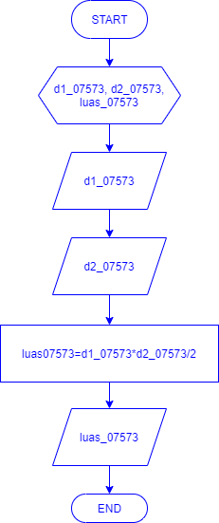

SOURCE CODE

#include <iostream>

#include <math.h>

using namespace std;

int main() {

float d1_07573,d2_07573,luas_07573;

cout<<"## Menghitung Luas Layang-Layang ##" <<endl;

cout<<"=================================="<<endl;

cout<<"masukan d1_07573: " <<endl;

cin>>d1_07573;

cout<<"masukan d2_07573: " <<endl;

cin>>d2_07573;

luas_07573=d1_07573*d2_07573/2 ;

cout<<"hasil luas_07573: " << luas_07573<<endl;

cout<<"=================================" <<endl;

return 0;

}